  Reading Time: An initial 2 minutes | MATHEMATICS METHODS : UNITS 1 & 2, 2020  Test 1 – (10%)  1.2.1 – 1.2.8
Time Allowed  45 minutes |  | First Name Surname | Marks  43 marks

Circle your Teacher’s Name: Benko Bestall Fraser-Jones Goh Koulianos Luzuk Rudland Tanday

Assessment Conditions: (N.B. Sufficient working out including diagrams must be shown to gain full marks)

- Calculators: Allowed

- Formula Sheet: Provided

- Notes: Not Allowed

Question 1

( 1, 1, 1 & 1 = 4 marks)

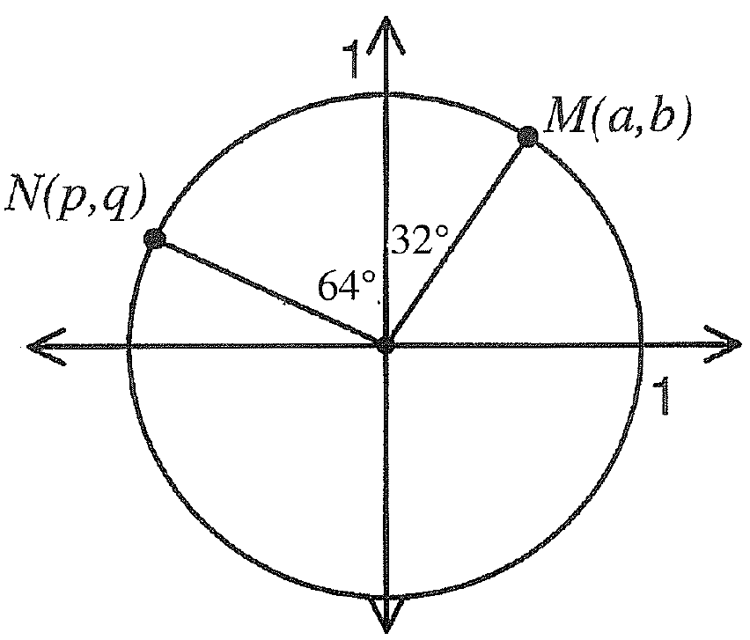

Two points N(p,q) and M(a,b) are plotted on the unit circle above.
In terms of a, b, p and/or q, determine the following.

- sin 26˚

- cos 154˚

- cos 26˚

- tan 122˚

Question 2

(2, 2 = 4 marks)

- Express the following angles in radians. Answers should be simplified, in exact values and in terms of .
(i) 45˚ (ii) 160 ̊

(b) Express the following angles in degrees.

(i) $\frac{3π}{5}$ radians (ii) 2.2 radians (round to nearest degree)

Question 3

(5 marks)

A parallelogram has side lengths of 25 and 30 cm and an area of 700cm². Find the length of the longest diagonal.

Question 4

(4 marks)

Triangle ACO is a right angled triangle with OA = 10cm, AC = 20cm and the size of angle OAC = 90˚. A circle of radius 10cm is drawn, centre O. Find the area of that part of the triangle OAC not lying in the circle.

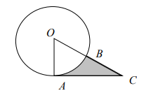

Question 5

(4 marks)

Points A and B lie on the circumference of a circle with centre O and radius 12cm. If the major arc AB has a length of 60cm, find the area of the minor sector AOB.

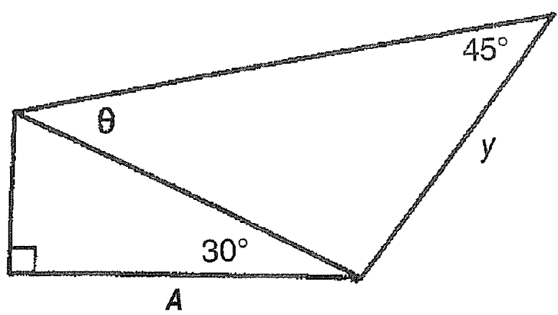
Question 6

(4 marks)

For the diagram on the right show that

y = 2$\sqrt{2}$A sinθ A

Question 7

(6 marks)

The diagram below shows two overlapping circles of radii 4 cm and 5 cm, where the size of angle MAN is 80°. Determine the area of the region common to both circles.

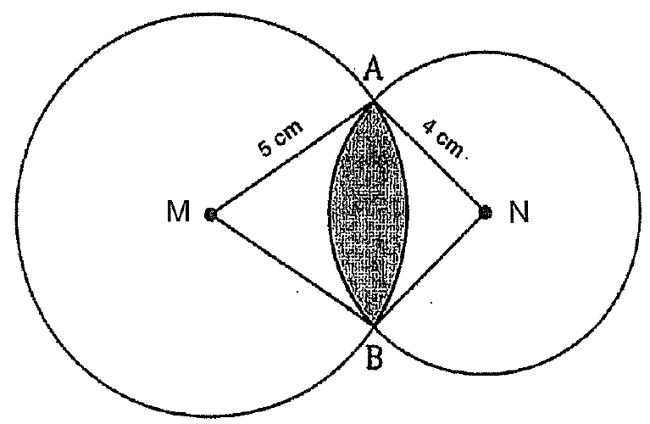

Question 8

(6 marks)

Ken and Sofia set out in different directions from their campsite. Ken walks 2150m
on a bearing of 316°, whilst Sofia walks for 2000m on an unknown bearing. When they finish walking the distance between them is 2696m. What are the possible bearings that Sofia could have used?

Question 9

(6 marks)

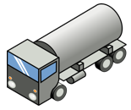
A tanker, truck A, is loaded with petrol however receives a tyre puncture. Another tanker that is empty, truck B, is sent to be loaded with all the petrol from the tank of truck A. Both trucks have cylindrical tanks.
Truck A has a tank of radius 1.7 m and a length of
6 m. The tank is filled with petrol to a height of 1.58 m.

Truck B has the same length but a radius of 1.5m.

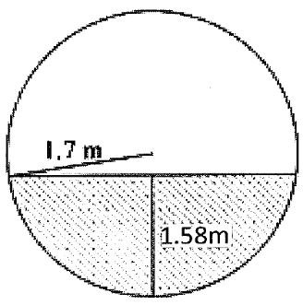
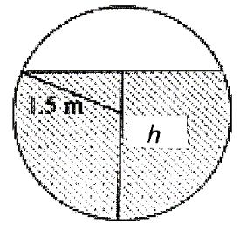

Circular ends of the petrol tanks.
The drivers are concerned as Truck B has a smaller tank. How high will the petrol reach in the tank of Truck B?

End of Paper

